Email: patents@cumail.in
INSTRUCTIONS:
1. Go to File → Download → Microsoft Word (.docx)
2. Download the IDF in your local storage.
3. Explain your invention comprehensively in the form.
4. Save your IDF file with the name of the Title of your invention. e.g.: "A Smart Electric Kettle".
5. Upload the duly filled IDF below.
INVENTOR DETAIL:
NAME: | Mohammad Saood
GENDER: | Male
EMAIL: | saoodvision@gmail.com
MOBILE NO: | 8750737014
DEPARTMENT: | Computer Science & Engineering (AI & ML)
DESIGNATION: | M.E. 1st Year Student
SCANNED HAND SIGNATURE: | [Attach scanned signature]
OTHER INVENTOR DETAIL:
NAME: | Mayank Yadav
GENDER: | Male
EMAIL: | mayaank@gmail.com
MOBILE NO: | 8750737014
DEPARTMENT: | Computer Science & Engineering (AI & ML)
DESIGNATION: | M.E. 1st Year Student
SCANNED HAND SIGNATURE: | [Attach scanned signature]
A) Please enlist the Key concepts and terms / Keywords / Synonyms used in the Invention.
S. No | Keywords for invention which has to be searched | Synonyms
1 | Wearable health band | Smart band; fitness tracker; smartwatch; wrist wearable
2 | Multi-agent AI system | AI council; agent panel; ensemble of agents; committee of models
3 | Specialist agent | Domain expert model; physiology / context / behaviour / goals agent
4 | Agent deliberation / debate | Machine reasoning; argumentation; structured disagreement
5 | Consensus gating | Agreement threshold; quorum; confidence gate; decision release rule
6 | Explainable recommendation | Transparent 'why'; rationale; justification; reasoned advice
7 | Context-aware personalisation | Situation awareness; goal-aligned coaching; adaptive nudging
1. TITLE OF INVENTION (15 words max)
Second Chair: A Wearable Health Band with a Deliberating Council of Specialist AI Agents
(Alternative titles: “The Quorum”, “Not So Fast” — a consensus-gated wearable advisor.)
2. PROBLEM STATEMENT & BACKGROUND
Explain the real-life problem your invention solves. Avoid technical jargon.
Problem Statement:
Millions of people wear fitness bands and smartwatches to make better daily decisions about their health, money, and time — for example whether to eat that burger, skip the gym, go to bed, or take a break. But today’s wearables only show raw numbers (“heart rate 92, 6,000 steps”) and a single, one-size-fits-all tip (“stand up”, “breathe”). That single suggestion is generated by one fixed rule or model that does not weigh the many, often conflicting, sides of a real-life situation. It does not know that the user is stressed, running late, behind on a weight-loss goal, and out with friends all at the same time. As a result the advice is generic, easy to distrust, and easy to ignore — and users cannot see why a recommendation was made, so they cannot judge whether to follow it. Everyone who relies on a wearable to change a habit (dieting, saving money, sleeping better, managing stress or a chronic condition) faces this gap between ‘lots of data’ and ‘one decision I can actually trust’.
Existing Solutions / Prior Methods (if known):
Current products and methods used to address this problem, and why they fall short:
• Mainstream wearables (Apple Watch, Fitbit, Garmin, Samsung) — show data and a single threshold-based alert, but give one flat suggestion with no reasoning and no awareness of the user’s wider context or goals.
• Single-model AI coaching apps — use one recommender model / rule engine; a single model can be confidently wrong and offers no internal ‘second opinion’ or check before advising.
• Academic ensemble / multi-agent debate methods — research on multi-agent and ‘society of mind’ systems and LLM debate improves answer quality, but has not been packaged on-device for a wearable that gates advice on genuine, reasoned consensus.
• Context-aware reminder apps — rule-based nudges (calendar/context reminders) do not reconcile conflicting objectives (health vs. mood vs. budget) and never explain the trade-off.
None of these convene multiple specialist viewpoints that argue about the user’s situation and then release a single recommendation only when they truly agree for the right reasons, together with a short, transparent explanation.
3. OBJECTIVE OF THE INVENTION
• To move a wearable from showing data and one flat tip to delivering a single, trustworthy decision produced by several specialist AI agents.
• To make each recommendation context-aware and goal-aligned by combining physiology, situation, habits, and the user’s stated goals.
• To release advice only when the agents reach genuine consensus for sound reasons, and otherwise stay silent or ask one clarifying question.
• To make every recommendation explainable by attaching a short ‘why’ so the user can trust and act on it.
• To run privately and efficiently on/near the band so personal data is protected.
INVENTION DETAILS
Describe your invention as if you are explaining it to a non-technical administrator.
Summary of the Invention:
The invention is a wearable health band, ‘Second Chair’, that does not just track the user — it convenes a panel (a ‘council’) of specialist AI agents that each look at the user’s current situation from a different angle, discuss and argue about it, and then tell the user the single best decision — but only when they truly agree, and for the right reasons. Instead of one flat suggestion from one model, the band acts like a wise ‘second chair’ sitting beside the user who quietly says ‘hang on, think about this’. Four specialist agents — a Physiology agent (heart rate, sleep, glucose, stress), a Context agent (place, time, calendar, weather, who you are with), a Behaviour/Habit agent (what you usually do and what you have done today), and a Goals agent (what you said you want — lose weight, save money, sleep more) — form their own opinions and debate them (for example, ‘recommend the burger’ vs. ‘you are stressed and behind on your goal’). A deliberation engine reconciles the arguments and an agreement gate releases one recommendation with a short explanation only when there is well-reasoned consensus; otherwise the band stays quiet or asks a single question. This solves the stated problem by turning ‘lots of data’ into one decision the user can understand and trust.
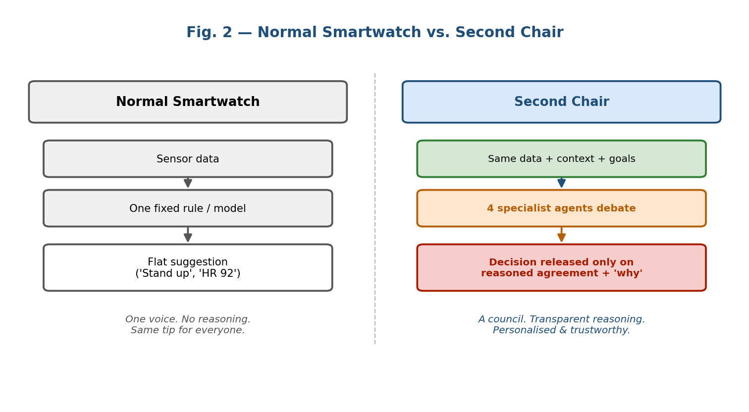
Fig. 2 — A normal smartwatch gives one flat tip; Second Chair convenes a council and releases a reasoned, consensus-gated decision.
Technical Description – How it Works (step-by-step):
The working is described in the order: input / starting material → key components → processing / interaction → output / final result.
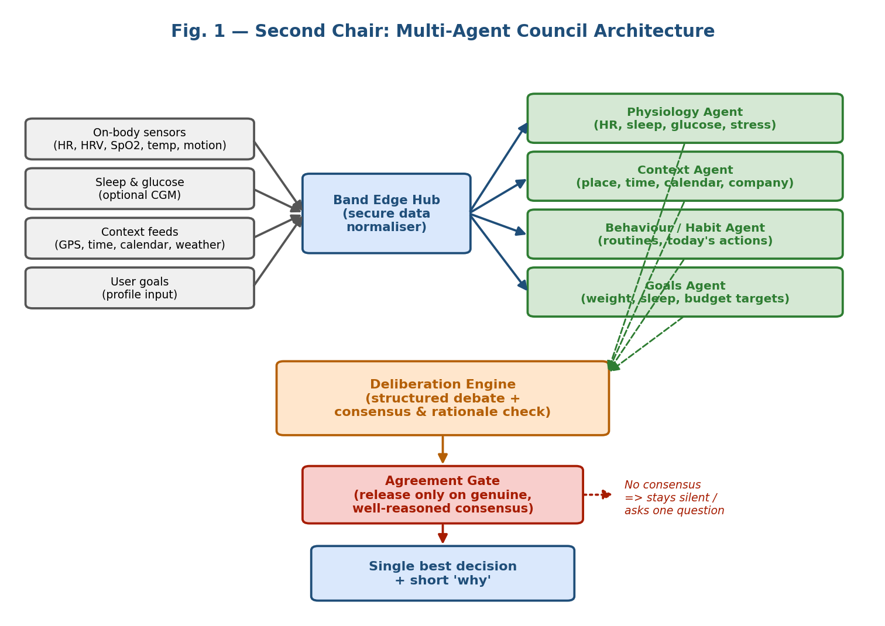
Fig. 1 — System architecture: sensors and context feed an edge hub, four specialist agents deliberate, and an agreement gate releases a single explained decision.
Input / starting material:
• On-body sensor signals: heart rate, heart-rate variability, SpO₂, skin temperature, and motion/steps from the band.
• Physiological extensions: sleep stages and, optionally, glucose from a paired continuous glucose monitor (CGM).
• Context feeds: GPS location, time of day, calendar events, weather, and (with permission) who the user is with.
• User goals: what the user said they want — e.g. lose weight, save money, sleep more — captured once in a profile and updated over time.
Key components / parts of the device and their functionality:
• (a) Sensor array — wristband housing the sensors listed above; captures the raw signals.
• (b) Band Edge Hub — an on-band secure module that cleans, time-aligns and normalises all signals and context into one ‘situation snapshot’, and protects private data.
• (c) Council of specialist agents — four specialist AI agents, each reasoning only from its own angle: Physiology (HR, sleep, glucose, stress), Context (place, time, calendar, weather, company), Behaviour/Habit (usual routines and today’s actions), and Goals (the user’s stated targets). Each produces its own recommendation with reasons.
• (d) Deliberation engine — lets the agents exchange and challenge each other’s recommendations (argue: e.g. ‘recommend the burger’ vs. ‘you are stressed and behind on your goal’), surfacing evidence and resolving conflicts.
• (e) Agreement gate — checks whether the agents have reached genuine agreement for sound reasons (not a shallow or coincidental match); only then is a decision released.
• (f) Output & explanation module — delivers the single best decision plus a short ‘why’ on the band screen / companion app; if there is no consensus it stays silent or asks one question.
Processing / interaction between components (software flow):
1. Capture — the band continuously collects physiology, context, behaviour and goal signals.
2. Distribute — the Band Edge Hub builds one normalised situation snapshot and passes it to all four agents.
3. Assess — each specialist agent independently forms its own recommendation and the reasons behind it.
4. Debate — the deliberation engine lets the agents argue, cite evidence, and counter one another until positions stabilise.
5. Gate — the agreement gate evaluates whether there is genuine, well-reasoned consensus.
6. Decide — if YES, the band shows one recommendation with a short explanation; if NO, it stays silent or asks a single clarifying question.
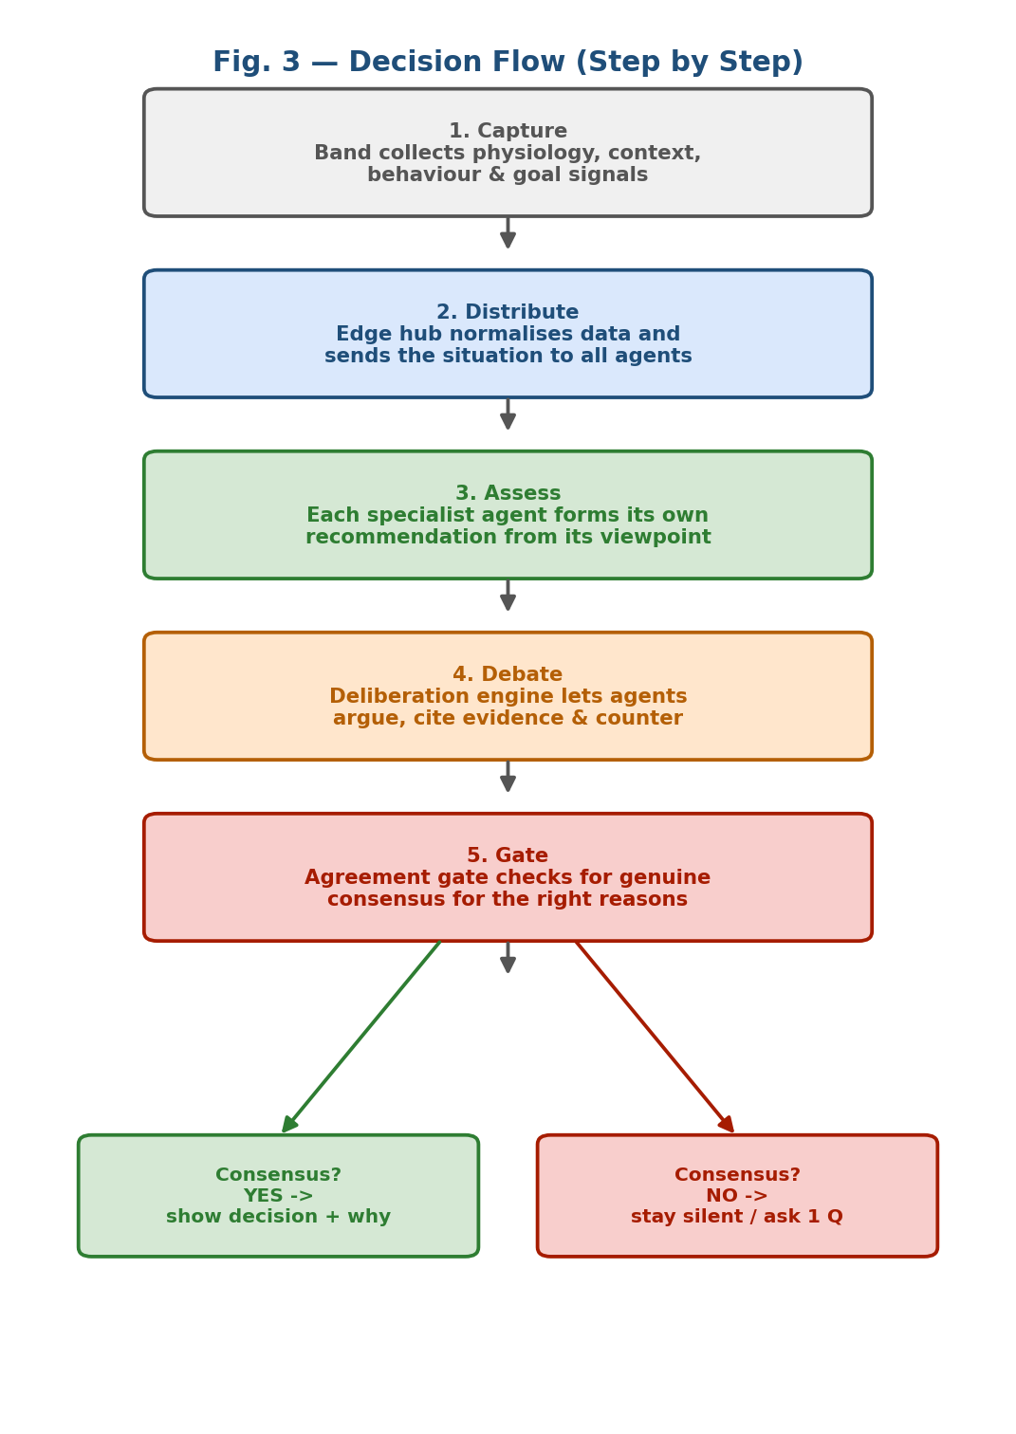
Fig. 3 — Step-by-step decision flow, from signal capture to a consensus-gated, explained recommendation.
Output / final result:
A single, trustworthy recommendation shown at the right moment (e.g. ‘Skip the burger tonight — you’re stressed and behind on your weight goal; have the grilled wrap instead’) together with a short, plain-language ‘why’. When the council does not genuinely agree, the band deliberately says nothing or asks one clarifying question rather than pushing a low-confidence tip.
***Note:
This invention is software embedded within a wearable device. Figures 1 and 3 show, step-wise, how the software (edge hub → agents → deliberation → agreement gate → output) works together with the band hardware and each part’s functionality.
NOVEL ASPECTS OF THE INVENTION
Clearly state what is new compared to existing solutions.
• Council instead of a single voice: a wearable that runs multiple specialist AI agents which independently assess the same situation from physiology, context, behaviour and goals — rather than one fixed rule or single model.
• Structured agent debate on-device: the agents actively argue and challenge each other’s recommendations, surfacing the real trade-offs in a decision, packaged for a resource-constrained wearable.
• Consensus-gated release for the right reasons: a novel agreement gate that releases a recommendation only when the agents genuinely agree with sound, non-coincidental reasoning — and otherwise stays silent or asks one question. This ‘earn-the-right-to-advise’ rule is the key inventive step.
• Built-in explainability: every released decision carries a short ‘why’ derived from the winning arguments, unlike the opaque single tips of current bands.
• Goal-aligned, context-aware reconciliation: conflicting objectives (health vs. mood vs. budget vs. social context) are explicitly reconciled before advising.
Advantages
Advantages | Yes / No
Cost effective | Yes
Improved efficiency | Yes
Eco-friendly | Yes
Higher accuracy | Yes
User-friendly | Yes
Advantages (why should anyone use it?):
• Higher accuracy & trust: combining four expert viewpoints and gating on reasoned consensus produces better, more reliable decisions than one model.
• Improved efficiency: users get one clear, actionable decision instead of raw data plus generic tips they must interpret themselves.
• User-friendly & transparent: a short ‘why’ with every recommendation, and silence when unsure, means fewer annoying, low-value nudges.
• Cost effective: runs on existing band-class hardware with edge processing; no new dedicated hardware and reduced cloud dependence.
• Eco-friendly / privacy-friendly: on-device edge processing lowers continuous cloud data transfer and energy use, and keeps personal data local.
• Personalised: advice is aligned to the user’s own goals and live context, not a one-size-fits-all rule.
6. DRAWINGS OR SUPPORT MATERIAL
The following figures are included in this disclosure:
• Fig. 1 — Multi-agent council system architecture (sensors → edge hub → four specialist agents → deliberation engine → agreement gate → explained output).
• Fig. 2 — Comparison of a normal smartwatch (one flat tip) against Second Chair (reasoned, consensus-gated decision).
• Fig. 3 — Step-by-step decision flowchart from signal capture to consensus-gated recommendation.
(Figures are embedded in Section 3 above and may also be attached separately as high-resolution images.)
7. ABSTRACT (150 words)
A wearable health band, ‘Second Chair’, that turns raw sensor data into a single trustworthy decision. Unlike conventional wearables that display numbers and one flat tip from a single model, the band convenes a council of specialist AI agents — physiology, context, behaviour/habit and goals — that each assess the user’s situation from their own angle. A band edge hub normalises on-body sensor signals, context feeds and stated goals into a situation snapshot shared with all agents. A deliberation engine lets the agents argue and reconcile conflicting recommendations, and an agreement gate releases advice only when they reach genuine consensus for sound reasons, always with a short explanation; otherwise the band stays silent or asks one clarifying question. The result is accurate, context-aware, goal-aligned and explainable guidance that users can understand and trust, delivered efficiently and privately through on-device edge processing.
[Word count: 141]

